AI Lab 11 Submission

Name: Yash Raj
Roll Number: 24k-0737

Task01:
import numpy as nm
import matplotlib.pyplot as mtp
import pandas as pd
from sklearn.cluster import KMeans
from sklearn.preprocessing import StandardScaler
import numpy as np

nm.random.seed(42)

n = 200

df = pd.DataFrame({
'CustomerID': range(1, n+1),
'Gender': nm.random.choice(['Male', 'Female'], n),
'Age': nm.random.randint(18, 70, n),
'Annual Income (k$)': nm.random.randint(15, 150, n),
'Spending Score (1-100)': nm.random.randint(1, 100, n)
})

df = pd.get_dummies(df, columns=['Gender'])

X = df.drop(columns=['CustomerID'])

age = X[['Age']]
other_features = X.drop(columns=['Age'])

scaler = StandardScaler()
other_scaled = scaler.fit_transform(other_features)

X_scaled = np.concatenate([age.values, other_scaled], axis=1)

kmeans_no_scaling = KMeans(n_clusters=5, init='k-means++', random_state=42)
clusters_no_scaling = kmeans_no_scaling.fit_predict(X)

kmeans_scaling = KMeans(n_clusters=5, init='k-means++', random_state=42)
clusters_scaling = kmeans_scaling.fit_predict(X_scaled)

df['cluster_no_scaling'] = clusters_no_scaling
df['cluster_with_scaling'] = clusters_scaling

print(df[['CustomerID', 'cluster_no_scaling', 'cluster_with_scaling']])

mtp.scatter(df['Annual Income (k$)'], df['Spending Score (1-100)'], c=clusters_no_scaling)
mtp.title('Clusters without Scaling')
mtp.xlabel('Annual Income')
mtp.ylabel('Spending Score')
mtp.show()

mtp.scatter(df['Annual Income (k$)'], df['Spending Score (1-100)'], c=clusters_scaling)
mtp.title('Clusters with Scaling')
mtp.xlabel('Annual Income')
mtp.ylabel('Spending Score')
mtp.show()

Output:
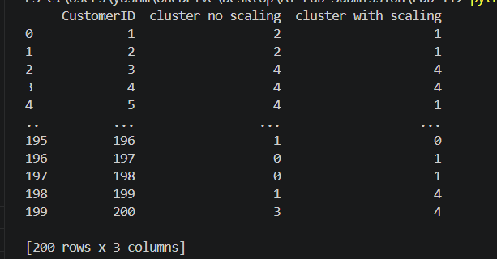
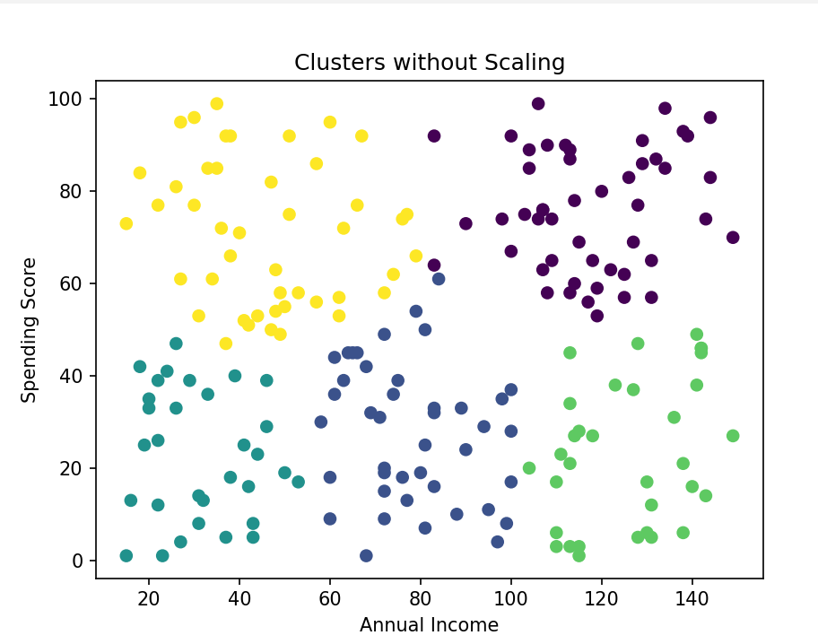
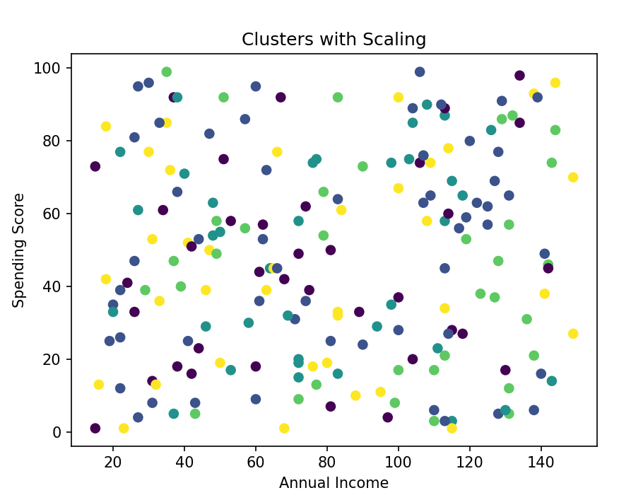
Task02:
import pandas as pd
from sklearn.cluster import KMeans
from sklearn.preprocessing import StandardScaler

data = {
'vehicle_serial_no': [5, 3, 8, 2, 4, 7, 6, 10, 1, 9],
'mileage': [150000, 120000, 250000, 80000, 100000, 220000, 180000, 300000, 75000, 280000],
'fuel_efficiency': [15, 18, 10, 22, 20, 12, 16, 8, 24, 9],
'maintenance_cost': [5000, 4000, 7000, 2000, 3000, 6500, 5500, 8000, 1500, 7500],
'vehicle_type': ['SUV', 'Sedan', 'Truck', 'Hatchback', 'Sedan', 'Truck', 'SUV', 'Truck', 'Hatchback', 'SUV']
}

df = pd.DataFrame(data)

df_encoded = pd.get_dummies(df, columns=['vehicle_type'])

X = df_encoded.drop(columns=['vehicle_serial_no'])

kmeans_no_scaling = KMeans(n_clusters=3, random_state=42)
df['cluster_no_scaling'] = kmeans_no_scaling.fit_predict(X)

scaler = StandardScaler()
X_scaled = scaler.fit_transform(X)

kmeans_scaling = KMeans(n_clusters=3, random_state=42)
df['cluster_with_scaling'] = kmeans_scaling.fit_predict(X_scaled)

print(df[['vehicle_serial_no', 'cluster_no_scaling', 'cluster_with_scaling']])

Output:
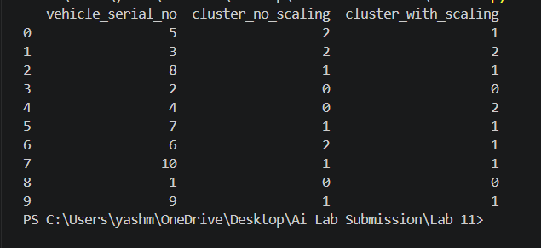
Task03:
import pandas as pd
import numpy as np
import matplotlib.pyplot as plt
from sklearn.preprocessing import StandardScaler
from sklearn.cluster import KMeans

np.random.seed(42)
n_students = 100

df = pd.DataFrame({
'student_id': range(1, n_students + 1),
'GPA': np.round(np.random.uniform(2.0, 4.0, n_students), 2),
'study_hours': np.random.randint(5, 40, n_students),
'attendance_rate': np.random.randint(50, 100, n_students)
})

print("Generated Dataset Preview:")
print(df.head())

X = df[['GPA', 'study_hours', 'attendance_rate']]

scaler = StandardScaler()
X_scaled = scaler.fit_transform(X)

inertia = []
for k in range(2, 7):
kmeans = KMeans(n_clusters=k, random_state=42)
kmeans.fit(X_scaled)
inertia.append(kmeans.inertia_)

plt.figure()
plt.plot(range(2, 7), inertia, marker='o')
plt.title("Elbow Method for Optimal K")
plt.xlabel("Number of Clusters (K)")
plt.ylabel("Inertia")
plt.show()

optimal_k = 3
kmeans = KMeans(n_clusters=optimal_k, random_state=42)
df['cluster'] = kmeans.fit_predict(X_scaled)

# 8. Final Dataset Output
print("\nFinal Dataset with Cluster Labels:")
print(df[['student_id', 'cluster']])

plt.figure()
plt.scatter(df['study_hours'], df['GPA'], c=df['cluster'])
plt.title("Student Clusters based on Study Hours and GPA")
plt.xlabel("Study Hours")
plt.ylabel("GPA")
plt.show()

Output:
